Hostel Room Allocation System

### Software Design Description

Ashutosh Rai

205119021

Table Of Contents

1. Introduction 2
   1. Purpose 2
   2. Objective 3
   3. Scope of the Project 3
   4. Overview of Project 3
2. Data Design 3
   1. Entity Relationship Diagram 3
   2. Conceptual Schema 4
3. Entities and Attributes 5
   1. Hostel 5
   2. Administrator 6
   3. Student 6
   4. Room 7
   5. Visitors 7
   6. Furniture 8

References 8

# Introduction

The Software Design Document is a document to provide documentation which will be used to aid in software development by providing the details for how the software should be built. Within the Software Design Document is narrative and graphical documentation of the software design for the project including ER Diagrams, Conceptual Schema, and other supporting requirement information.

## Purpose

The purpose of the Software Design Document is to provide a description of the design of a system fully enough to allow for software development to proceed with an understanding of what is to be built and how it is expected to build. The Software Design Document provides information necessary to provide the description of the details for the software and system to be built.

## Objective

* + - To deal with Hostel Management System in an easy and an efficient manner.
    - Create strong and secrete database that allows for any connection in a secret way, to prevent any outside or inside attacks.

## Scope of the Project

* + - Hostel Management System is designed for Hostel (like schools, Universities).
    - There will be predefined criteria for the Reservation to the hostels.
    - He/She checks the attested application forms of the students obtained from the internet and verify it with the student database.
    - If the students are found eligible then they are allotted to the hostel Room.

## Overview of Project

Hostel Room Allocation System is a web application which aims at computerization of the current procedure of allocating hostel rooms. Currently, the process involves students filling up the forms and submitting them in respective hostel offices which involves a lot of paperwork, hence less efficient.

# Data Design

## Entity Relationship Diagram

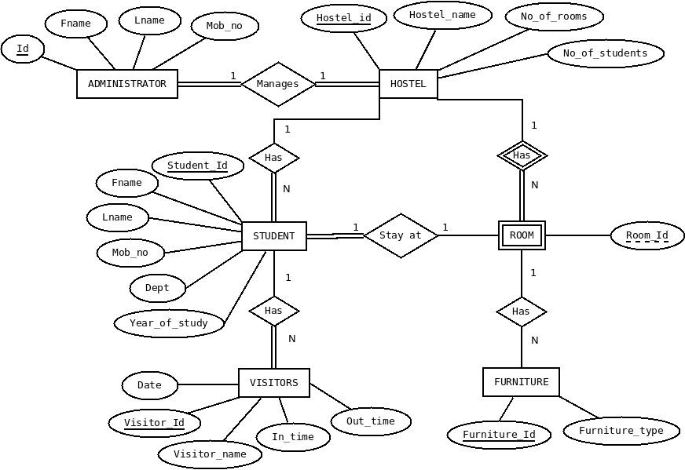

## Conceptual Schema

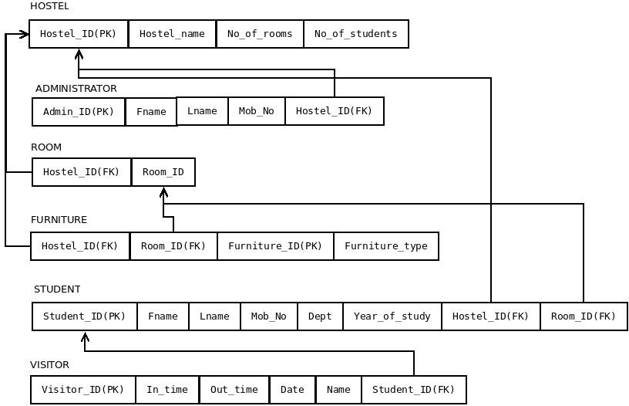

1. Entities and Attributes

This section of the document explains the entities used in the project, their attributes and how they will work together. Basically, this is intended to make the design more easy and understandable for everyone.

#### Entities

1. Hostel
2. Administrator
3. Student
4. Room
5. Visitor
6. Furniture

## Hostel

An Institution has many hostels and each hostel is represented using this ‘Hostel’ entity. Hostel model takes part in the following relationships.

* + 1. Administrator manages **Hostel**.
    2. **Hostel** has Students.
    3. **Hostel** has Rooms.

#### Attributes

|  |  |  |
| --- | --- | --- |
| **Name** | **Data Type** | **Type** |
| Hostel_ID | integer | Primary Key attribute |
| Hostel_name | string | Non_key attribute |
| No_of_rooms | integer | Non_key attribute |
| no_of_students | integer | Non_key attribute |

## Administrator

Every hostel has an administrator and is represented using the ‘administrator’ entity. Administrator entity takes part in following relationships.

* + 1. **Administrator** manages Hostel.

#### Attributes

|  |  |  |
| --- | --- | --- |
| **Name** | **Data Type** | **Type** |
| ID | integer | Primary Key attribute |
| Fname | string | Non_key attribute |
| Lname | string | Non_key attribute |
| Mob_No | string | Non_key attribute |
| Hostel_id | integer | Foreign Key attribute |

## Student

Every hostel has students and they are represented by the ‘student’ entity. Student entity participates in the following relationships.

* + 1. Hostel has **Students**.
    2. **Student** has visitor.
    3. **Students** stay at room

#### Attributes

|  |  |  |
| --- | --- | --- |
| **Name** | **Data Type** | **Type** |
| Student_ID | integer | Primary Key attribute |
| Fname | string | Non_key attribute |
| Lname | string | Non_key attribute |

|  |  |  |
| --- | --- | --- |
| Mob_No | string | Non_key attribute |
| Dept | string | Non_key attribute |
| Year_of_study | integer | Non_key attribute |
| Hostel_id | integer | Foreign Key attribute |
| Room_id | integer | Foreign Key attribute |

## Room

Every Hostel has rooms and they are represented using ‘room’ entity. Room entity participates in the following relationships.

* + 1. Hostel has **Rooms**.
    2. Student stays at **room**.
    3. **Room** has Furniture.

#### Attributes

|  |  |  |
| --- | --- | --- |
| **Name** | **Data Type** | **Type** |
| Hostel_ID | integer | Foreign Key attribute |
| Room_ID | integer | Partial Key attribute |

## Visitors

Every student has visitors and they are represented using ‘Visitor’ entity. Visitor entity participates in the following relationships.

* + 1. Student has **visitors**.

#### Attributes

|  |  |  |
| --- | --- | --- |
| **Name** | **Data Type** | **Type** |
| Visitor_ID | integer | Primary Key attribute |
| In time | Date-time field | Non_key attribute |

|  |  |  |
| --- | --- | --- |
| Out time | Date-time field | Non_key attribute |
| Date | Date-time field | Non_key attribute |
| Name | string | Non_key attribute |
| Student_id | integer | Foreign Key attribute |

## Furniture

Every room has furniture and they are represented using ‘furniture’ entity. Furniture participated in following relationships.

* + 1. Room has **Furniture**.

#### Attributes

|  |  |  |
| --- | --- | --- |
| **Name** | **Data Type** | **Type** |
| Furniture_ID | integer | Primary Key attribute |
| Room_ID | integer | Foreign Key attribute |
| Hostel_ID | integer | Foreign Key attribute |
| Furniture_type | string | Non_key attribute |

# References

##### <http://fadicool007.blogspot.com/p/project.html>

##### <https://github.com/pranavjindal999/Hostel-Management-System>